Name of Journal: World Journal of Methodology
Manuscript NO: 98201
Manuscript Type: ORIGINAL ARTICLE

Basic Study
Selective procedure for the instant identification of cellular apoptosis induced by natural products

Cui YY. Selective and instant procedure for apoptosis identification

Ying-Yu Cui

Ying-Yu Cui, Department of Cell Biology, Institute of Medical Genetics, State Key Laboratory of Cardiology, Tongji University School of Medicine, Shanghai 200331, China

Author contributions: Cui YY designed and performed the research, and analyzed the data and wrote the manuscript.

Supported by 2023 Key R&D Projects of Tongji University, No. 150029607160-24323; and Industrial Key Program Foundation of Guangdong Province: R&D of Natural Novel Anticancer Drugs, No. 2004B10401033.

Corresponding author: Ying-Yu Cui, PhD, Associate Professor, Teacher, Department of Cell Biology, Institute of Medical Genetics, State Key Laboratory of Cardiology, Tongji University School of Medicine, No. 500 Zhennan Road, Putuo District, Shanghai 200331, China. yycui@tongji.edu.cn

Received: June 20, 2024
Revised: November 19, 2024
Accepted: December 23, 2024
Published online: September 20, 2025

Abstract
BACKGROUND
Recently, the identification of cell apoptosis induced by natural products has become research hotspot and frontier in the biopharmaceutical and food industries under the umbrella of global green development worldwide. Traditionally, cell apoptosis is identified using morphological, biochemical, and cell cycle experiments, which is time consuming, and experimental materials are not from the same group, and it is very hard to ensure the identity and veracity of results of former and latter experiments.

AIM
To establish a selective, instant, and practical protocol to identify cell apoptosis induced by natural products.

METHODS
A one transient cell processing procedure (OTCPP) was used to detect human colorectal cancer LoVo cell apoptosis after treatment with Pinus massoniana bark extract (PMBE) at the morphological, biochemical, and cell cycle levels. The methods used included treatment with DNA gel electrophoresis, fluorescence microscopy, and flow cytometry.

RESULTS
In PMBE-treated LoVo cells, we observed a DNA ladder on gel electrophoresis and fluorescence microscopy revealed "nuclear shrinkage, chromatin condensation or fragmentation". In addition, flow cytometry showed an "obvious apoptosis curve". Thus OTCPP achieved synchronous detection of the morphology, biochemistry, cell cycle, and the DNA content of the cells.

CONCLUSION
OTCPP can quickly identify apoptosis and measure the apoptosis rate, thereby unifying qualitative and quantitative analysis.

Key Words: Apoptosis identification; Fluorescence microscopy; DNA gel electrophoresis; Flow cytometry; Pinus massoniana bark extract; One transient cell processing procedure

Cui YY. Selective procedure for the instant identification of cellular apoptosis induced by natural products. World J Methodol 2025; 15(3): 98201
URL: https://www.wjgnet.com/2222-0682/full/v15/i3/98201.htm
DOI: https://dx.doi.org/10.5662/wjm.v15.i3.98201

Core Tip: According to the global green development hypothesis, the identification of cell apoptosis induced by natural products is a research hotspot. However, routine laboratory identification of apoptosis suffers from experimental errors and poor repeatability. Herein, we explored the simultaneous morphological, biochemical and molecular identification of apoptosis, while reducing experimental errors. We established a protocol to instantly identify apoptosis following natural product treatment, termed one transient cell processing procedure (OTCPP), comprising eleven steps. It could identify apoptosis of cultured LoVo cells in a little as 4 days. The OTCPP procedure is easy, rapid and high efficient, especially for researchers in developing countries.

INTRODUCTION
Apoptosis is a normal physiological phenomenon[1,2], widely involved in development, tissue homeostasis, and some pathological processes, further becomes a frontier of bio-medical research. Classic methods for apoptosis identification include fluorescence microscopy, gel electrophoresis, and flow cytometry, among which DNA ladder resulting from gel electrophoresis is regarded as gold standard. However, these methods have different protocols and are performed with different cells cultured in different dishes, respectively, consuming more time. Apoptotic cells, whose degraded smaller DNA leaked out, fixed with ethanol and then stained with fluorescein, will become sub-diploids because of their DNA contents less than those of G1 phase[3,4]. The extracted DNA can be effectively controlled by phosphate-citric acid buffer (0.2 M, pH7.8), and the leaked DNA can form DNA ladder under gel electrophoresis, while the residual cells’ cell cycle distribution can be analyzed with flow cytometry[5,6].
Currently, the global green development hypothesis is promoting research into natural products, thus they have become hotspot in the biopharmaceutical and food industries. Certain natural products can promote or inhibit cell growth, or even induce their apoptosis[7]. The identification of natural product-induced apoptosis is thus an important subject. Consequently, the present study aimed to identify the effect of Pinus massoniana bark extract (PMBE) on human colorectal cancer LoVo cells to demonstrate the integrative procedure termed one transient cell processing procedure (OTCPP). OTCPP produces uses different instruments to achieve apoptosis detection, with relatively satisfactory results. We believe that OTCPP will play an important role in accelerating the progress of basic research, clinical diagnosis, and screening candidate natural drugs.

MATERIALS AND METHODS
Reagents
The Institute of Songzhen nutritional resource (Guangzhou, China) supplied the PMBE. The other reagents comprised HEPES (Amresco, Solon, OH, United States), Roswell Park Memorial Institute (RPMI) 1640 (HyClone, Logan, UT, United States), Penicillin-Streptomycin (Penicillin 10000 units/mL, Streptomycin 10000 µg/mL) (Invitrogen, Waltham, MA, United States), Fetal bovine serum (FBS; Sijiqing Co. Hangzhou, China), Trypsin (HyClone), propidium iodide (PI) (Sigma, St. Louis, MO, United States), RNase A (Sino-American Biotechnology Co., Beijing, China) and Proteinase K (Merck, Darmstadt).

Cell line
This study used the human colorectal cancer cell line LoVo (ATCC, Manassas, VA, United States; number CCL-229).

Equipment
The OTCPP process used an incubator, fluorescence microscope (BH-2, Olympus, Tokyo, Japan), electrophoresis apparatus (Bio-Rad, Hercules, CA, United States), a flow cytometer (ELITE, Beckman Coulter, Indianapolis, IN, United States), and MULTICYCLE analysis software (Phoenix Flow Systems, San Diego, CA, United States).

OTCPP Protocol
(1) Cell Culture and Treatment: Two wells of LoVo cells were cultured in complete RPMI 1640 media (10% FBS, 10 mmol/L HEPES, 100 IU/mL penicillin, 100 µg/mL streptomycin) in a flat-bottom plate (Costar, Corning, NY, United States), respectively, until to the logarithmic growth period (about 10⁴⁻⁶ cells/mL), then labeled as experimental group and control group, further adding 140 µg/mL PMBE to the culture media or not, respectively, all incubating for 24 hours; (2) Cell Collection and fixation: 1 mL of 0.25% trypsin was used to trypsinize the LoVo cells (1-2 × 10⁷) at 37℃ for appropriate time. Then, add 0.5% FBS-RPMI 1640 media to stop trypsinization and gentle pipetting the cell clumps into single cells. The cells were transferred into an Eppendorf tube, centrifuged at 100 g for 5 minutes, and then discarded the supernatant. The cell pellet was washed twice using 1 × PBS with centrifugation at 100 g for 5 minutes each time. The cells were resuspended into single cell status using 1 × PBS (20 µL), added with 2 mL 70% ethanol, and placed at -20℃ overnight to fix the cells; (3) Centrifuged 100 g, 10 minutes, discarded supernatant to remove ethanol; (4) Resuspended in 0.5 mL 1 × PBS, transferred to a new micro-tube, centrifuged 150 g, 10 minutes, discarded supernatant; (5) Added 40 µL of 0.2 M phosphate-citric acid buffer (pH7.8), RT 30 minutes, intermittent shaking; (6) Centrifuged 100 g, 10 minutes, and then transferred the supernatant to a new micro-tube, incubated on ice for fluorescence observation and flow cytometry analysis; (7) Added 3 µL of 0.25% NP40, 3 µL of RNase A solution (1 mg/mL) to the supernatant, vortexed, further incubated at 37℃, 30 minutes; (8) Added 3 µL of Proteinase K (1 mg/mL) to the mixture, vortexed thoroughly, and then incubated at 37℃ for 30 minutes; (9) Then, 16 µL of the mixture was mixed thoroughly with 2 µL of 6 × DNA loading buffer, resolved on agarose gel at 220V, 2 hours, and then stained with EB. The gel was visualized under UV light; (10) Cell pellets of step (6) were resuspended in 0.5 mL 1 × PBS. Then, added 10 µL of Proteinase K (1 mg/mL), vortexed gently, and left RT, 30 minutes, then washed the cells two times using 1 × PBS with centrifugation 100 g, 5 minutes each time, and discarded supernatant, resuspended again in 20 µL 1 × PBS into single cells. Then, added 300 µL of DNA staining solution (containing 150 µg/mL PI and 20 U/mL RNase A) and incubated RT, 30 minutes; and (11) Placed a drop of the single cell suspension on a air-drying glass slide, covered with a coverslip, and observed under a fluorescence microscope (G.B filter, 400 ×). The remaining cell suspension for flow cytometry, analyzing the ratio of apoptotic cells.

Duration of use
4 days (2 ON incubation, 1 ON fixation, and 1 day with 2-3 hours of operation time).

Key notes
(1) Trypsinize the cells just well; (2) Rotation speed no more than 150 g; (3) Resuspend the cells into a single cell suspension using a small amount of 1 × PBS, then fix them with ethanol; and (4) Recommend removing large multi-cellular aggregates with a nylon monofilament mesh screen before analysis on the flow cytometer, ensuring that the cells flow through the cytometer in a single line.

RESULTS
Using a one-station operation for one-time cell culture and OTCPP, obtained enough experimental materials to identify cell apoptosis with different instruments, letting synchronous identification of LoVo cell apoptosis at morphological, biochemical, cell cycle, and DNA content level, respectively, come true. Further, reach the perfect combination of qualitative and quantitative analysis, which not only shortened the experimental time, but also completed the task in four working days rather than the original 9 working days. The results were quite satisfactory (Figure 1, Figure 2, and Figure 3). Briefly, an integrative protocol for apoptosis identification and measurement was established.
PI staining of control LoVo cells and cells treated with 140 µg/mL PMBE for 24 hours under a fluorescence microscope with a G.B. filter. Normal cells (N) depicted in the panel show light and homogeneous staining of their nuclei. In contrast, apoptotic cells (A) in the panel show thick and irregular staining of their nuclei. Magnification, 400 ×.
DNA ladder from apoptotic LoVo cells treated with 140 µg/mL PMBE for 24 hours. Results of gel electrophoresis showing that relatively low molecular-weight DNA had extruded out of apoptotic LoVo cells. M DNA marker DL2000; 1 Control; 2 PMBE Treatment
Results of flow cytometry analysis of control LoVo cells and LoVo cells treated with 140 µg/mL PMBE for 24 hours: (1) Shows a normal cell cycle distribution of untreated LoVo cells stained with PI, showing no obvious apoptotic-sub-G1 curve, but with 10.9% of the cells showing spontaneous apoptosis; (2) Shows the cell cycle distribution of LoVo cell treated with PMBE and stained with PI. There is an obvious apoptotic-sub-G1 curve before the G1 curve, with 31.4% of the cells showing apoptosis; and (3) Shows the statistical histogram of LoVo cell apoptosis induced by PMBE treatment compared with Control. ªP < 0.05 vs Control, n = 3, mean ± SD.

DISCUSSION
Through culturing cells once and subsequent OCTPP, obtain enough experimental materials to detect the target cell apoptosis with different instruments, reaching the simultaneous identification of apoptosis at morphological, biochemical, cell cycle, and DNA content level, respectively, further realize the unity of quantitative and qualitative analyses, shortening the experimental time obviously, while producing relatively good results.
Current measures for apoptosis identification involve detecting morphological, biochemical, and DNA content changes. At morphological level, fluorescence microscopy requires culturing cells on coverslips until monolayers form, which involves in the complicated steps and the inferior picture quality due to cell-cell junctions. What’s more, it is qualitative other than quantitative. At molecular level, DNA for gel electrophoresis was not extracted classically after cells are lysed with buffer, not only time-consuming, but also potentially toxic, and possibly shearing DNA as well, further decreasing the reproducibility of experiments. Although pulse alternative field gel electrophoresis can avoid shearing DNA via pre-embedding cells in low-melting-point agarose, which will increase the time taken and the cost of the experiments. Moreover, these DNA detection methods are qualitative, or at most semi-quantitative. By contrast, flow cytometry is simple, rapid, quantitative, and multi-parametric.
Performing these three independent experiment results analyses (morphological, biochemical, and DNA content analyses) is time consuming, and the experimental materials are frequently not from the same cell culture batch, making it hard to ensure the consistency and veracity of the results. Herein, prefixed the cells in 70% cold ethanol, then 0.2 M phosphate-citrate buffer at pH7.8 was used to extract DNA, and then spin 100 g, 5-10 minutes to make the smaller DNA leaked out thoroughly. The supernatant was then sequentially incubated with RNase A and proteinase K, further for direct electrophoresis. The cell pellets were stained with PI, a proportion of which was for slide preparation and fluorescence microscope observation, the remaining for flow cytometry. OTCPP allows the rapid identification of the classical hallmarks of apoptosis, which owns merits as follows: (1) 70% cold ethanol fixation makes cells stored for relatively longer time before analysis, without any significant DNA degradation from pathogenic infection and cell autolysis; (2) Multiple targets (nuclear shrinkage, DNA ladder and sub-G1 curve) can be detected almost simultaneously, shortening the experimental time sharply; (3) Culturing cells on coverslips for nuclear morphology observation can be omitted completely; (4) DNA extraction is simple and rapid, with no phenol, chloroform, or other toxic reagents, and the inconvenience of pulse field gel electrophoresis; (5) 0.2 M phosphate-citrate buffer (pH 7.8) helps the smaller DNA fragments completely extruded out of apoptotic cells[8], increasing the sensitivity and specificity of flow cytometry; and (6) The same experimental samples can be ensured, enhancing the consistency during experimentation. Briefly and vividly, OTCPP successfully achieved three birds of cell apoptosis in one stone. Thus, OTCPP is an improvement on classical methods of apoptosis identification, and researchers can select it according to their different purposes and own experimental conditions. However, OTCPP might have potential limitations, unsuitable for long-lived cells lacking or just weak proliferative ability, e.g. neural cells, myocardial cells, and stem cells with relatively small numbers in different tissues in organisms.

CONCLUSION
The present study presents a novel selective procedure for the rapid identification of human colon cancer LoVo cell apoptosis induced by the natural product, PMBE, using the OTCPP protocol. The use of OTCPP might pave the way for future basic and clinical research by optimizing experimental conditions (e.g. single-molecular augmented capture and imaging) to improve detection sensitivity in other cell types and/or disease models, e.g. neurons, cardiomyocytes and stem cells in critical diseases.

ACKNOWLEDGEMENTS
I would like to express my sincere gratitude to my laboratory mates for their invaluable assistance which significantly improved this work.

REFERENCES
1 Kerr JF, Wyllie AH, Currie AR. Apoptosis: a basic biological phenomenon with wide-ranging implications in tissue kinetics. Br J Cancer 1972; 26: 239-257 [PMID: 4561027 DOI: 10.1038/bjc.1972.33]
2 Nössing C, Ryan KM. 50 years on and still very much alive: 'Apoptosis: a basic biological phenomenon with wide-ranging implications in tissue kinetics'. Br J Cancer 2023; 128: 426-431 [PMID: 36369364 DOI: 10.1038/s41416-022-02020-0]
3 Darzynkiewicz Z, Bruno S, Del Bino G, Gorczyca W, Hotz MA, Lassota P, Traganos F. Features of apoptotic cells measured by flow cytometry. Cytometry 1992; 13: 795-808 [PMID: 1333943 DOI: 10.1002/cyto.990130802]
4 Costigan A, Hollville E, Martin SJ. Discriminating Between Apoptosis, Necrosis, Necroptosis, and Ferroptosis by Microscopy and Flow Cytometry. Curr Protoc 2023; 3: e951 [PMID: 38112058 DOI: 10.1002/cpz1.951]
5 Hotz MA, Gong J, Traganos F, Darzynkiewicz Z. Flow cytometric detection of apoptosis: comparison of the assays of in situ DNA degradation and chromatin changes. Cytometry 1994; 15: 237-244 [PMID: 8187583 DOI: 10.1002/cyto.990150309]
6 Gong J, Traganos F, Darzynkiewicz Z. A selective procedure for DNA extraction from apoptotic cells applicable for gel electrophoresis and flow cytometry. Anal Biochem 1994; 218: 314-319 [PMID: 8074286 DOI: 10.1006/abio.1994.1184]
7 Cui YY, Xie H, Wang JF. [Transient detection of apoptosis of human liver cancer cells induced by Pinus massoniana bark extract (PMBE) in vitro]. Zhongguo Zuzhihuaxue Yu Xibaohuaxue Zazhi 2005; 14: 80-83
8 Zhu XQ, Wang GS, Zhang XJ, Zhao Q. [Effects of sodium ferculate on the viability and apoptosis of human hepatoma BEL-7404 cells]. Shijie Huaren Xiaohua Zazhi 1999; 7: 715-716

Footnotes
Institutional review board statement: No human and/or animal subjects was involved in the present study.

Conflict-of-interest statement: All the authors report no relevant conflicts of interest for this article.

Data sharing statement: No additional data are available.

Open-Access: This article is an open-access article that was selected by an in-house editor and fully peer-reviewed by external reviewers. It is distributed in accordance with the Creative Commons Attribution NonCommercial (CC BY-NC 4.0) license, which permits others to distribute, remix, adapt, build upon this work non-commercially, and license their derivative works on different terms, provided the original work is properly cited and the use is non-commercial. See: https://creativecommons.org/Licenses/by-nc/4.0/

Provenance and peer review: Invited article; Externally peer reviewed.

Peer-review model: Single blind

Specialty type: Medical laboratory technology
Country of origin: China
Peer-review report’s classification
Scientific Quality: Grade C
Novelty: Grade C
Creativity or Innovation: Grade C
Scientific Significance: Grade C

P-Reviewer: Guo D S-Editor: Qu XL L-Editor: A P-Editor:

Figures and Tables
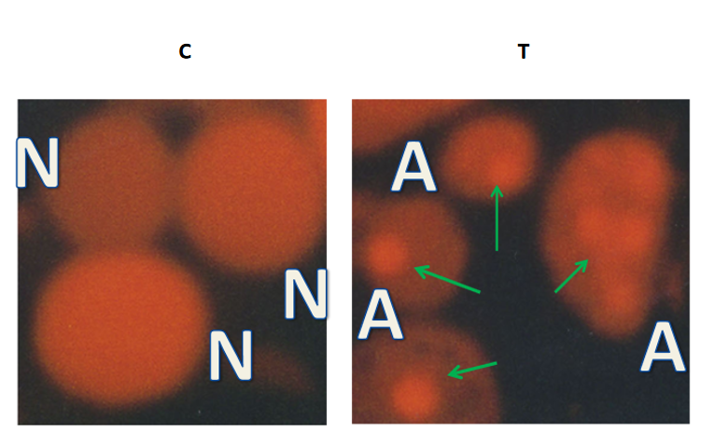
Figure 1 Fluorescence microscopy observation of LoVo cell apoptosis. Propidium iodide staining of LoVo cells untreated and treated with 140 µg/mL Pinus massoniana bark extract for 24 hours under fluorescence microscope with G.B. filter. Normal cells depicted in the panel show light and homogeneous staining of their nuclei. In contrast, apoptotic cells represented in the panel show thick and irregular staining of their nuclei as a result of chromatin condensation and nuclear fragmentation. Magnification, 400 ×. N: Normal cells; A: Apoptotic cells.
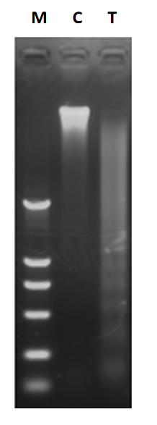
Figure 2 DNA gel electrophoresis of LoVo cell apoptosis. DNA ladder of apoptotic LoVo cells treated with 140 µg/mL Pinus massoniana bark extract for 24 hours. Results of gel electrophoresis of relative low-molecular-weight DNA oozed out of apoptotic LoVo cells. M DNA marker DL2000; 1 Control; 2 Treatment.

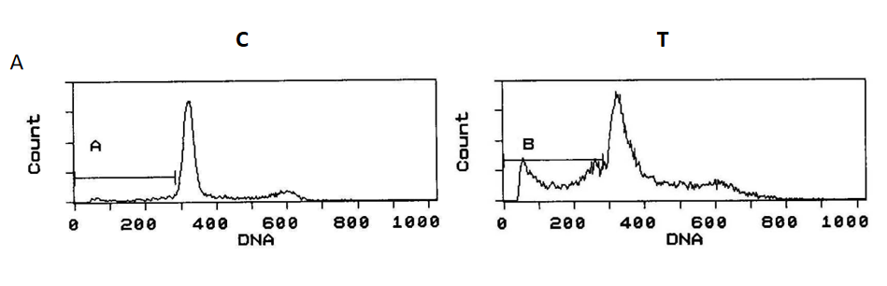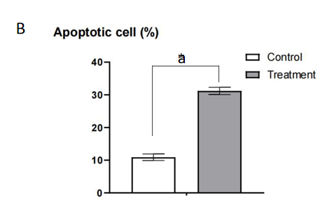
Figure 3 Pathological changes of LoVo cells after treatment with 140 µg/mL Pinus massoniana bark extract for 24 hours or not by flow cytometry analysis. A: Control group, a normal cell cycle distribution of an untreated LoVo cell line stained with propidium iodide (PI), there is no obvious apoptotic curve- sub-G1 curve but with a percentage of 10.9% spontaneous apoptosis. Treatment group, altered cell cycle distribution of a treated LoVo cell line stained with PI, there is an obvious apoptotic curve-sub- G1 curve before G1 curve with a gross percentage of 31.4% induced apoptosis; B: Statistical histogram of LoVo cell apoptosis induced by PMBE treatment compared with Control. ªP < 0.05 vs Control, n = 3, mean ± SD.

