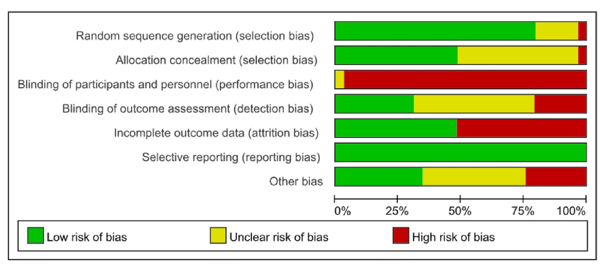
Figure S1. Risk-of-bias assessment of randomised controlled trials evaluating psychological therapy vs control in individuals with inflammatory bowel disease using the Cochrane Risk of Bias 2.0 tool.
Study-level judgements are presented for the five RoB 2.0 domains and the overall risk-of-bias rating for each trial.
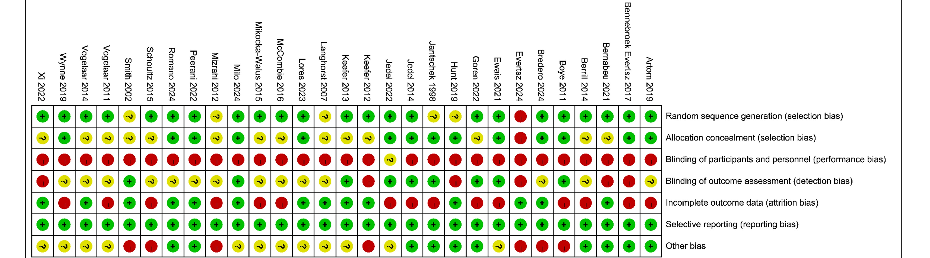
Figure S2. Risk-of-bias summary of included randomised controlled trials evaluating psychological therapy vs control in individuals with inflammatory bowel disease using the Cochrane Risk of Bias 2.0 tool.
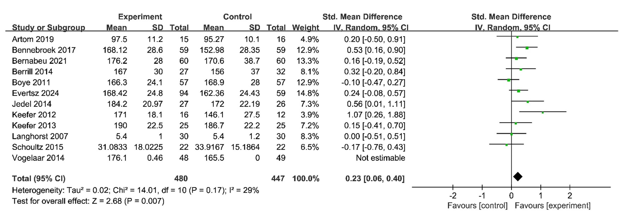
Figure S3. Forest plot of randomised controlled trials reporting the effect of psychological therapy vs control on IBDQ total score in individuals with inflammatory bowel disease at completion of therapy.
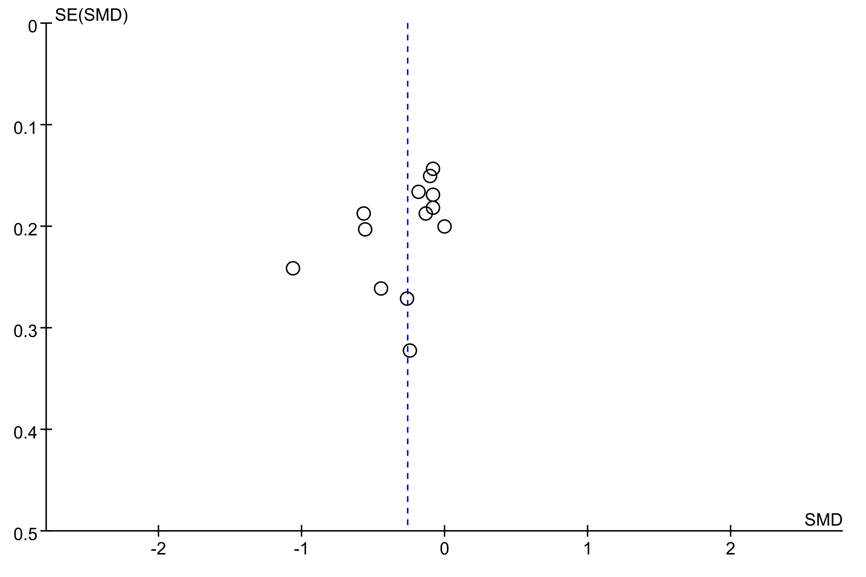
Figure S4. Funnel plot of randomised controlled trials reporting the effect of psychological therapy vs control on depression scores in individuals with inflammatory bowel disease.
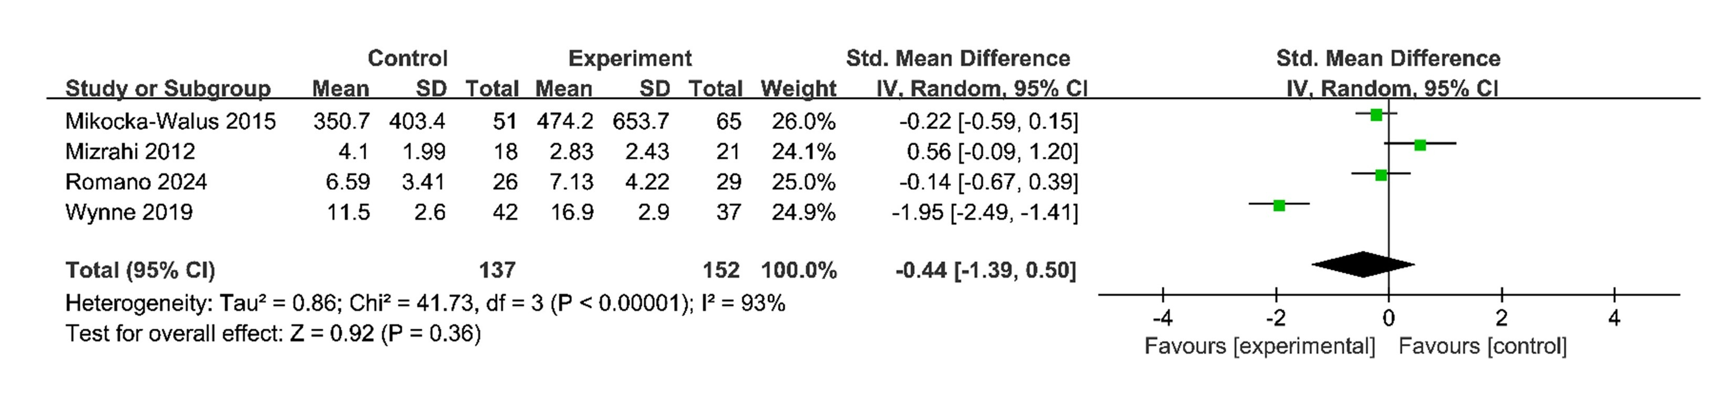
Figure S5. Forest plot of randomised controlled trials reporting the effect of psychological therapy vs control on stress scores in individuals with inflammatory bowel disease at completion of therapy.
Negative SMDs favor psychological therapy, indicating reduced stress.
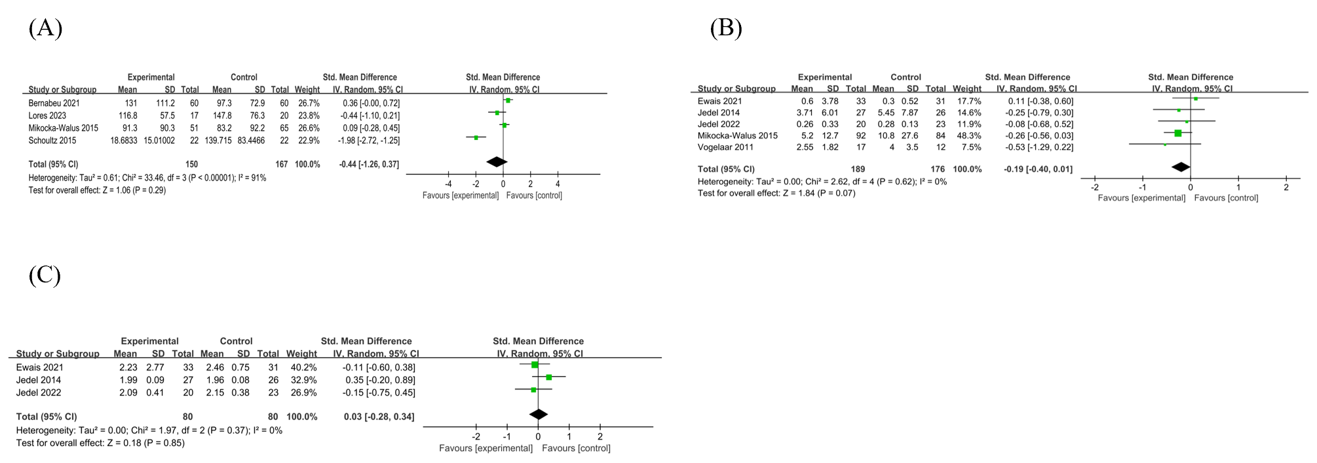
Figure S6. Forest plots of randomised controlled trials reporting the effect of psychological therapy vs control on clinical disease activity and inflammatory biomarkers in individuals with inflammatory bowel disease at completion of therapy.
(A) Crohn’s Disease Activity Index (CDAI); (B) C-reactive protein (CRP); (C) interleukin-6 (IL-6). Negative SMDs indicate reduced disease activity or inflammation in the psychological therapy group. CDAI, Crohn’s Disease Activity Index; CRP, C-reactive protein; IL-6, interleukin-6.
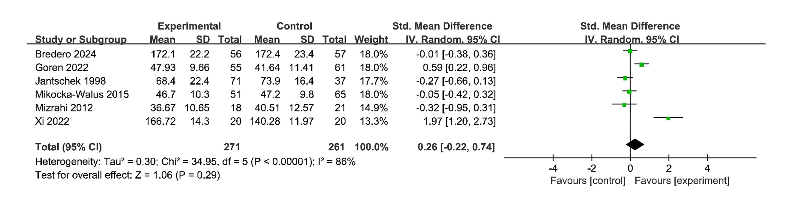
Figure S7. Forest plot of randomised controlled trials reporting the effect of psychological therapy vs control on physical quality-of-life outcomes in individuals with inflammatory bowel disease at completion of therapy.

Table S1. Characteristics of Included Studies.
Study (year) | Participants | Country | Intervention | Control | Follow-up duration | Outcomes repoerted
Jantschek (1998) | 108 patients with CD | Germany | 10 sessions of supportive/counseling approaches over 12 months | Standardised drug  therapy including  tapered prednisolone  and sulfasalazine | 24 months | Physical quality of life (QOL-physical)
Smith (2002) | 50 patients with CD 50 patients with UC | UK | 3-6-monthly sessions of stress management training  over 12 months | Routine clinical  follow-up | 12 months | Anxiety and depression (HADS-A, HADS-D)
Langhorst (2007) | 60 patients with UC | Germany | Weekly stress-management program with mindfulness and dietary advice over 10 weeks | Usual medical care | 12 months | IBDQ total score; IBDQ subscales (bowel, emotional, systemic, social)
Boye (2011) | 114 patients with IBD | Norway and Germany | CBT-based program including psychoeducation and relaxation, with three initial group sessions, weekly individual sessions for 6-9 weeks, and up to three booster sessions over 12 months | Treatment as usual | 18 months | IBDQ total score
Vogelaar (2011) | 29 patients with CD  with fatigue | Netherlands | Solution-focused therapy or problem-solving therapy delivered over 3 months, consisting of five sessions of solution-focused therapy or ten sessions of problem-solving therapy | Treatment as usual | 6 months | C-reactive protein (CRP)
Keefer (2012) | 28 patients with CD | USA | Weekly project-management sessions incorporating cognitive behavioural therapy principles and social learning theory, delivered over 6 weeks | Treatment as usual | 8 weeks | IBDQ total score; IBDQ subscales (bowel, emotional, social, systemic)
Mizrahi (2012) | 39 patients with IBD | Israel | Three-session relaxation training with guided imagery delivered over 5 weeks | Waiting list control | 5 weeks | Physical quality of life (QOL-physical); Depression and stress(visual analogue scale, VSA)
Keefer (2013) | 50 patients with UC | USA | Supportive/counseling gut-directed hypnotherapy delivered as weekly sessions for 7 weeks | Attention control | 12 months | IBDQ total score
Berrill (2014) | 59 patients with IBD | UK | Cognitive behavioural-based multi-convergent therapy including mindfulness meditation, delivered in 6 sessions over 16 weeks | Standard medical  therapy | 12 months | IBDQ total score; subscales (bowel, emotional, systemic, social)
Jedel (2014) | 53 patients with UC | USA | Mindfulness-based stress reduction intervention with weekly sessions over 8 weeks including sitting meditation, body scans, yoga postures and awareness of personal reactions to everyday events | Attention control | 12 months | C-reactive protein  Interleukin-6 (IL-6)  IBDQ total score; subscales (bowel, emotional, systemic, social)
Vogelaar (2014) | 97 patients with IBD  with fatigue | Netherlands | Stress-management/coping skills training using solution-focused therapy delivered in six sessions over three months with one booster session at 6 months | Treatment as usual | 9 months | IBDQ total score
Mikocka-Walus (2015) | 176 patients with IBD | Australia | Internet-delivered or face-to-face cognitive behavioural therapy with weekly sessions over 10 weeks | Standard care | 12 months | Physical quality of life (QOL-physical); C-reactive protein (CRP); Anxiety (HADS-A); Depression (HADS-D); Stress (COPE questionnaire); Disease activity (CDAI)
Schoultz (2015) | 44 patients with IBD | UK | Mindfulness-based cognitive therapy with weekly sessions over 8 weeks (body scan, sitting and walking meditation, exercises) | Waiting list control | 6 months | IBDQ total score; Disease activity (CDAI)
McCombie (2016) | 199 patients with IBD | New Zealand | 8 sessions of computerized cognitive behavioural therapy over 12 weeks | Treatment as usual | 6 months | Anxiety (HADS-A); Depression (HADS-D)
Bennebroek Evertsz (2017) | 118 patients with IBD with reduced quality of life | Netherlands | 8 sessions of cognitive behavioural therapy over 8 weeks | Waiting list control | 14 weeks | IBDQ total score; Anxiety (HADS-A); Depression (HADS-D); IBDQ subscales (bowel, emotional, systemic, social)
Artom (2019) | 31 patients with IBD  with fatigue | UK | 8 sessions of cognitive behavioural therapy by telephone over 8 weeks | Self-help sheet | 12 months | IBDQ total score
Wynne (2019) | 79 patients with IBD with increased stress or a reduced quality of life | Ireland | 8 sessions of acceptance and commitment therapy over 8 weeks | Standard care | 20 weeks | Anxiety, depression and stress (DASS-21)
Hunt (2019) | 140 patients with IBD | USA | Cognitive behavioural therapy self-help book over 6 weeks | Waiting list control | 6 weeks | Anxiety (State-triat anxiety inventory, STAI); Depression (Beck depression inventory, BDI)
Bernabeu (2021) | 120 patients with IBD | Spain | Cognitive behavioural–based multicomponent group therapy incorporating mindfulness and acceptance and commitment elements delivered in 8 sessions over 8 weeks. | Treatment as usual | 8 weeks | IBDQ total score; Anxiety (Perceived Stress Questionnaire, PSQ); Depression (HADS-D); Disease activity (CDAI); IBDQ subscales (emotional, systemic, social)
Ewais (2021) | 64 patients with IBD with depression | Australia | Mindfulness-based cognitive behavioural therapy delivered in 8 sessions over 8 weeks | Waiting list control | 20 weeks | C-reactive protein (CRP); Interleukin-6 (IL-6)
Jedel (2022) | 43 patients with UC | USA | Mindfulness-based stress reduction delivered in eight sessions over 8 weeks | Attention control | 12 months | C-reactive protein (CRP); Interleukin-6 (IL-6)
Bredero (2024) | 113 patients | Netherlands | Mindfulness-based cognitive therapy delivered as weekly group sessions over 8 weeks including group meditation, cognitive behavioural exercises, psychoeducation and daily homework | Waiting list control | 3 months | Physical quality of life (QOL-physical); Anxiety (GAD-7); Depression (BDI)
Evertsz (2024) | 153 patients with IBD with poor quality of life, anxiety, depression | Netherlands | Cognitive behavioural based therapy, delivered as 8 weekly one hour individual face to face sessions by trained CBT therapists in hospital medical psychology departments | None (implementation study of IBD-specific CBT in routine clinical care) | 3.5 months | IBDQ total score; Anxiety (HADS-A); Depression (HADS-D); IBDQ subscales (bowel, emotional, systemic, social)
Goren (2022) | 116 patients with CD | Israel | Cognitive behavioural–based multicomponent intervention combining cognitive behavioural therapy and mindfulness-based stress reduction with daily exercise, delivered in 7 sessions over 3 months | Waiting list control | 3 months | Physical quality of life (QOL-physical)
Lores (2023) | 37 patients with IBD | Australia | Supportive/counseling approaches: Virtual gut-directed hypnotherapy (V-GDH), 7 weekly individual telehealth sessions adjunctive to standard medical care | Standard medical treatment | 12 months | Disease activity (CDAI)
Milo (2024) | 60 patients with IBD | Italy | Short-term psychodynamic psychotherapy added to standard medical therapy, delivered as an 8-week individual face-to-face program | Standard medical therapy | 12 months | Anxiety (GAD-7); Depression (Patient Health Questionnaire-9, PHQ-9)
Peerani (2022) | 101 patients with IBD with increased stress | Canada | Internet-delivered stress-management intervention delivered over 12 weeks | Standard care | 12 weeks | Anxiety (HADS-A); Depression (HADS-D);
Romano (2024) | 55 patients with IBD | Australia and New Zealand | 8-week online acceptance and commitment therapy program (3 therapist-led + 4 self-directed + 1 final therapist-led session) | Online psychoeducation program matched for format and contact | 3 months | Anxiety, depression and stress (DASS-21)
Xi (2022) | 40 patients with IBD | China | Mindfulness meditation over 3 months | Conventional nursing  methods | 3 months | Physical quality of life (QOL-physical)

