

End-organ protection in hypertension by the novel and selective Rho-kinase inhibitor, SAR407899

Matthias Löhn, Oliver Plettenburg, Aimo Kannt, Markus Kohlmann, Armin Hofmeister, Dieter Kadereit, Peter Monecke, Alexander Schiffer, Anke Schulte, Hartmut Ruetten, Yuri Ivashchenko
CITATION | Löhn M, Plettenburg O, Kannt A, Kohlmann M, Hofmeister A, Kadereit D, Monecke P, Schiffer A, Schulte A, Ruetten H, Ivashchenko Y. End-organ protection in hypertension by the novel and selective Rho-kinase inhibitor, SAR407899. World J Cardiol 2015; 7(1): 31-42
URL | http://www.wjgnet.com/1949-8462/full/v7/i1/31.htm
DOI | http://dx.doi.org/10.4330/wjc.v7.i1.31
OPEN ACCESS | Articles published by this Open-Access journal are distributed under the terms of the Creative Commons Attribution Non-commercial License, which permits use, distribution, and reproduction in any medium, provided the original work is properly cited, the use is non commercial and is otherwise in compliance with the license.
CORE TIP | Rho-kinase (ROCK) is considered an important ta-rget in cardiovascular diseases, e.g., hypertension and nephropathy. Currently available treatment only moderately alleviates the progression of chronic kidney diseases. We have identified a novel, potent and selective inhibitor of ROCK (SAR407899) and characterized its effects in vivo. The therapeutic efficacy of SAR407899 has been compared to the current standard treatment for hypertension in two animal models of hypertension, one of which is sensitive and the other insensitive (deoxycorticosterone acetate) to angiotensin converting enzyme-inhibition. ROCK-inhibition by SAR407899 may represent a new therapeutic option either as a monotherapy or in combination with existing modern therapeutics for the treatment of hypertension and its complications.
KEY WORDS | Hypertension; End organ damage; Rho-kinase; Angiotensin converting enzyme-inhibition
COPYRIGHT | © The Author(s) 2015. Published by Baishideng Publishing Group Inc. All rights reserved.
COPYRIGHT LICENSE | Order reprints or request permissions: bpgoffice@wjgnet.com
NAME OF JOURNAL | World Journal of Cardiology
ISSN | 1949-8462 ( online)
PUBLISHER | Baishideng Publishing Group Co., Limited, Flat C, 23/F., Lucky Plaza, 315-321 Lockhart Road, Wan Chai, Hong Kong, China
WEBSITE | http://www.wjgnet.com

ESPS Manuscript NO: 12549
Columns: Case Control Study

End-organ protection in hypertension by the novel and selective Rho-kinase inhibitor, SAR407899

Matthias Löhn, Oliver Plettenburg, Aimo Kannt, Markus Kohlmann, Armin Hofmeister, Dieter Kadereit, Peter Monecke, Alexander Schiffer, Anke Schulte, Hartmut Ruetten, Yuri Ivashchenko

Matthias Löhn, Oliver Plettenburg, Aimo Kannt, Markus Kohlmann, Armin Hofmeister, Dieter Kadereit, Peter Monecke, Alexander Schiffer, Anke Schulte, Hartmut Ruetten, Yuri Ivashchenko, Translational Medicine, Sanofi-Aventis,
Industriepark Hoechst, 65926 Frankfurt am Main, Germany
Author contributions: Löhn M performed the majority of experiments, designed the study and wrote the manuscript; Plettenburg O, Hofmeister A and Kadereit D designed and synthetized SAR407899; Kannt A performed an initial compound screening; Kohlmann M performed the pharmacokinetics of SAR407899; Monecke P and Schiffer A were involved in structural biology and modeling required for the compound optimization; Schulte A performed the histology; Ruetten H and Ivashchenko Y were also involved in writing and editing the manuscript.
Ethics approval: All animal experiments were performed in accordance with the German law for the protection of animals and current Aventis Laboratory Animal Science and Welfare (LASW) guidelines.
Informed consent: Not applicable.
Conflict-of-interest: There is no conflict-of-interest to disclose. All authors are employees of Sanofi-Aventis Deutschland GmbH.
Data sharing: Technical appendix, statistical code, and dataset available from the corresponding author at Matthias.loehn@sanofi.com. Participants gave informed consent for data sharing. No additional data are available.
Open-Access: This article is an open-access article which was selected by an in-house editor and fully peer-reviewed by external reviewers. It is distributed in accordance with the Creative Commons Attribution Non Commercial (CC BY-NC 4.0) license, which permits others to distribute, remix, adapt, build upon this work non-commercially, and license their derivative works on different terms, provided the original work is properly cited and the use is non-commercial. See: http://creativecommons.org/licenses/by-nc/4.0/
Correspondence to: Dr. Matthias Löhn, Translational Medicine, Sanofi-Aventis, Industriepark Hoechst, 65926 Frankfurt am Main, Germany. matthias.loehn@sanofi.com
Telephone: +49-69-30517118
Received: July 14, 2014
Peer-review started: July 15, 2014
First decision: November 3, 2014
Revised: December 12, 2014
Accepted: December 29, 2014
Article in press: January 4, 2015
Published online: January 26, 2015

Abstract
AIM: To compare the therapeutic efficacy of SAR407899 with the current standard treatment for hypertension [an angiotensin converting enzyme (ACE)-inhibitor and a calcium channel blocker] and compare the frequency and severity of the hypertension-related end-organ damage.

METHODS: Long-term pharmacological characte-rization of SAR407899 has been performed in two animal models of hypertension, of which one is sensitive to ACE-inhibition and the other is insensitive [deoxycorticosterone acetate (DOCA)]. SAR407899 efficiently lowered high blood pressure and significantly reduced late-stage end organ damage as indicated by improved heart, kidney and endothelial function and reduced heart and kidney fibrosis in both models of chronic hypertension.

RESULTS: Long term treatment with SAR407899 has been well tolerated and dose-dependently reduced elevated blood pressure in both models with no signs of tachyphylaxia. Blood pressure lowering effects and protective effects on hypertension related end organ damage of SAR407899 were superior to ramipril and amlodipine in the DOCA rat. Typical end-organ damage was significantly reduced in the SAR407899-treated animals. Chronic administration of SAR407899 significantly reduced albuminuria in both models. The beneficial effect of SAR407899 was associated with a reduction in leukocyte/macrophage tissue infiltration. The overall protective effect of SAR407899 was superior or comparable to that of ACE-inhibition or calcium channel blockade. Chronic application of SAR407899 protects against hypertension and hypertension-induced end organ damage, regardless of the pathophysiological mechanism of hypertension.

CONCLUSION: Rho-kinases-inhibition by the SAR407899 represents a new therapeutic option for the treatment of hypertension and its complications.

Key words: Hypertension; End organ damage; Rho-kinase; Angiotensin converting enzyme-inhibition

© The Author(s) 2015. Published by Baishideng Publishing Group Inc. All rights reserved.

Core tip: Rho-kinase (ROCK) is considered an important ta-rget in cardiovascular diseases, e.g., hypertension and nephropathy. Currently available treatment only moderately alleviates the progression of chronic kidney diseases. We have identified a novel, potent and selective inhibitor of ROCK (SAR407899) and characterized its effects in vivo. The therapeutic efficacy of SAR407899 has been compared to the current standard treatment for hypertension in two animal models of hypertension, one of which is sensitive and the other insensitive (deoxycorticosterone acetate) to angiotensin converting enzyme-inhibition. ROCK-inhibition by SAR407899 may represent a new therapeutic option either as a monotherapy or in combination with existing modern therapeutics for the treatment of hypertension and its complications.

Löhn M, Plettenburg O, Kannt A, Kohlmann M, Hofmeister A, Kadereit D, Monecke P, Schiffer A, Schulte A, Ruetten H, Ivashchenko Y. End-organ protection in hypertension by the novel and selective Rho-kinase inhibitor, SAR407899. World J Cardiol 2015; 7(1): 31-42 Available from: URL: http://www.wjgnet.com/1949-8462/full/v7/i1/31.htm DOI: http://dx.doi.org/10.4330/wjc.v7.i1.31

INTRODUCTION
Hypertension increases the risk of target organ damage, including heart hypertrophy, heart ischemia, kidney dysfu-nction or failure, cerebrovascular events and malfunction of the endothelial tissue^{[1-5]}. The contractile response of smooth muscle tissue is controlled at different levels by a tight balance of pro-contractile and relaxing mechanisms. In particular, it has been persuasively shown that Rho-kinases (ROCK1 and ROCK2) are intimately involved in the transmission of contractile signaling within smooth muscle tissue^{[6-13]}. Upon activation of the small GTPase RhoA by ligand-bound specific GPCRs, ROCKs, the downstream effectors of RhoA, phosphorylate the myosin light chain phosphatase and the myosin regulatory light-chain itself, resulting in a net increase in activated myosin. This promotes smooth muscle contraction and actin cytoskeleton re-organization. Inhibition of ROCKs leads to relaxation of vascular smooth muscle cells and, consequently, to a decrease in blood pressure^{[7,9,14-20]}. Several inhibitors of ROCK (in particular, fasudil and Y27632) have been extensively used to evaluate the role of ROCK in cardiovascular physiology and pathology. In addition, fasudil is used in Japan to treat cerebral vasospasm after focal cerebral ischemia or aneurysmal subarachnoid hemorrhage. However, both inhibitors have a moderate specificity, moderate potency and short duration of action in vivo that limit their clinical use. Therefore, the development of a more potent and specific inhibitor with a better pharmacokinetic profile is needed to explore the potential of ROCK inhibition in the therapy of hypertension and its complications. We have identified a novel ROCK-inhibitor, SAR407899, and previously characterized its acute effects in vitro and in vivo^{[21]}. Here, we describe the long-term effects of SAR407899 treatment in two animal models of hypertension, one being sensitive (Nω-Nitro-L-arginine methyl ester hydrochloride, LNAME) and the other being insensitive [deoxycorticosterone acetate (DOCA)] to angiotensin converting enzyme (ACE)-inhibition. The DOCA-induced hypertension model is characterized by a hypervolemic and low plasma renin status, which promotes resistance to ACE-inhibition, whereas the LNAME model is normovolemic and displays a high renin activity in plasma^{[22-24]}. The results of large clinical trials (IDNT, RENAAL and IRMA-2) revealed that the current standard treatment only modestly (approximately 20%) reduces the progression of chronic kidney diseases. From these data it can be concluded that a simple decrease of blood pressure is not sufficient for kidney protection. Our results indicate that chronic inhibition of the ROCK kinases efficiently controls blood pressure and significantly reduces the frequency and severity of the hypertension-related end organ damage.

MATERIALS AND METHODS
DOCA and LNAME-induced hypertension
Adult male Sprague Dawley rats (190 to 210 g, Harlan Winkelmann, Borchen, Germany), were treated with DOCA-salt or Nω-Nitro-L-arginine methyl ester hydr-ochloride (LNAME) to induce hypertension. To compare the pharma-cological potency of ROCK-inhibition with the current anti-hypertension drugs, the individual blood pressure lowering effect of the respective compounds was measured in spontaneous hypertensive rats (SHR). Oral application of SAR407899 at 3 mg/kg lowered blood pressure in conscious telemetred SHR by 26 ± 4 mmHg (n = 10), which was comparable to the action of amlodipine at 3 mg/kg (blood pressure reduction by 33 ± 8 mmHg, n = 10) and ramipril at 1 mg/kg (blood pressure reduction by 21 ± 7 mmHg, n = 10). Therefore, the animals were divided into the following groups: (1) Control; (2) DOCA or LNAME; (3) DOCA or LNAME + SAR407899 at 3 mg/kg; (4) DOCA or LNAME + SAR407899 at 10 mg/kg; (5) DOCA or LNAME + ramipril at 1 mg/kg; and (6) DOCA or LNAME + amlodipine at 3 mg/kg. All DOCA-salt treated animals underwent a unilateral nephrectomy, received a subcutaneous injection of DOCA (30 mg/kg; Sigma Chemical, St. Louis, MO, United States) dissolved in sesame oil once a week and 1% NaCl in the drinking water ad libitum. All LNAME groups received 40 mg/kg per day LNAME in the drinking water ad libitum. After a 4-wk treatment, the animals were placed into metabolic cages and 24 h-urine samples and blood samples were taken to analyze kidney function. Urinary and plasma creatinine levels were determined using standard kits (Roche diagnostics, Basel, Switzerland) on a Hitachi 912 E analyzer (Hitachi, Mountain View, Calif., United States). Urinary albumin was measured using a standard kit from Progen (Mikroflural, Progen, Heidelberg, Germany) and was normalized to urinary creatinine concentrations. After 5 wk of treatment, measurements of: (1) blood pressure (invasively, two hours after the last treatment); (2) organ weights; and (3) endothelial function were taken. The investigation conforms to the Guide for the Care and Use of Laboratory Animals published by the United States National Institutes of Health (NIH publication no. 85-23, revised 1996).

Invasive blood pressure measurement
The animals were anaesthetized with an intraperitoneal injection of thiopental (0.1 g/mL per 100 g body weight). The common carotid artery was catheterized with a heparinized microcatheter (diameter 1.6 mm, Vycon, France). Blood pressure was measured with a Hugo Sachs hemodynamic system (March-Hugstetten, Germany) using the software Hemodyn.

In vitro vascular and heart function
Assessment of in vitro vascular function was performed as described earlier^{[21,25,26]}. Heart function was determined using a Langendorff-setup in the working heart perfusion mode. This technique allows the heart to perform its physiological pumping action, i.e., it performs pressure/volume work. The working heart technique therefore provides a complete analysis of heart function. Heart power is an integrative parameter and is calculated by formula (1):
HW (J) = 133.3 [(N/m²)/mmHg] × (ALPmean-PLPmean) (mmHg) × SV (m³) (1)
+ 0.5 × 1.004 (kg/m³) × SV (m³) × {SV (m³)/[ × r² (m²) × ET (s)]}²
where HW-heart power, ALPmean-afterload pressure, PLPmean-preload pressure, SV-stroke volume, and ET-Ejection time. If not otherwise indicated, chemicals were obtained from Sigma (Deisenhofen, Germany).

RT PCR
Real-time quantitative PCR was performed using the QuantiTect Probe RT-PCR Kit (Qiagen, Hilden, Germany). Each sample was assayed in quadruplicate. For relative quantification of gene expression, the Ct method was used with GAPDH as a control. Amplification of the target and housekeeping genes was detected simultaneously using differently fluorescent-labeled Taq Man probes (Col1A1: Rn00801665_g1, CD3: Rn01417941_g1 and CD68: Rn01495634_g1), which were obtained from Applera/Applied Biosystems (Foster City, United States). Amplification linearity of the target and housekeeping genes within the multiplex RT-PCR was assessed by performing RT-PCR reactions with dilutions of the templates. RT-PCR reactions and data acquisition was performed using the iCycler-iQ-Thermocycler (Bio-Rad Laboratories GmbH, Munich, Germany). Relative gene expression was calculated as fold induction vs control samples.

Histology
Heart and kidneys underwent a standard fixation procedure and standard haematoxylin-eosin and sirius red staining. The hearts and kidneys were analyzed with regard to incidence and extent of fibrosis, inflammatory events, glomerulosclerosis and tubular atrophy. A semi-quantitative score was assigned to each specimen by an experienced pathologist ranging from 1 (minimal changes) to 4 (marked alterations) at a standard magnification of 4 to 20-fold. All histopathological analyses were performed in a blinded fashion. Anti-podocin staining was performed using anti-podocin antibodies (Sigma-Aldrich, United States).

Statistical analysis
All values are given as the mean and standard error of mean. Normality of the distribution and the homogeneity of variance were checked using the Levene test. For group comparisons, one-way analysis of variance (ANOVA) or two-way ANOVA was performed followed by Dunnett’s post-hoc test using the SAS version 8.2 software. Differences between groups were considered significant if P < 0.05; n represents the number of specimens or animals tested.
The statistical methods of this study were reviewed by and complies to the standard of Sanofi-Aventis GmbH Deutschland.

Results
Effect of SAR407899 on body weight, blood pressure and kidney function
The long-term effects of SAR407899 in DOCA- and LNAME-induced hypertension were compared to those of the current standard anti-hypertensive drugs, namely ramipril (ACE-inhibitor) and amlodipine (calcium channel blocker, CCB). Figure 1 depicts the effects of SAR407899 on body weight of the DOCA- and LNAME-hypertensive animals. Treatment with SAR407899 was well tolerated and showed a significant protective effect on body weight in both hypertensive animal models (Figure 1A and C). Factors involved in the continuous body weight loss are not known and most likely depend on hypertension related end-organ damage, including proteinuria. Ramipril showed protective effects on body weight only in the LNAME model (Figure 1D), whereas amlodipine significantly protected the DOCA hypertensive animals from body weight loss (Figure 1B).
Figure 2 demonstrates the effects of SAR407899 (3 mg/kg and 10 mg/kg), ramipril (1 mg/kg) and amlodipine (3 mg/kg) on blood pressure in the DOCA- (Figure 2A) and LNAME-treated rats (Figure 2B). SAR407899 effectively reduced blood pressure in both hypertensive models. Because the DOCA-induced hypertensive model is characterized by hypervolemia and resistance to ACE-inhibition, it was not surprising that ramipril had no significant effect on blood pressure. At the dose employed, amlodipine non-significantly lowered blood pressure in the DOCA rats. In the LNAME rats, all treatments significantly lowered blood pressure. In comparison to amlodipine and ramipril, SAR407899 showed superior blood pressure lowering effects at both doses in the LNAME rats. Thus, only SAR407899 was able to control blood pressure efficiently in both models and was therefore superior to the reference substances.
Kidney function (Figure 2C and D) was assessed by the measurement of albuminuria. In both models, SAR407899 dose-dependently reduced albuminuria. Ramipril significantly reduced albuminuria in only the LNAME model but not in the DOCA model. At the dose administered, amlodipine did not significantly reduce albuminuria in the DOCA or LNAME models. The lack of efficacy of amlodipine has been linked to the inability of CCB’s to dilate renal efferent vessels, which is critical for improvement of the renal microcirculation.

Long term treatment effects of SAR407899 on heart and endothelial function
Figure 3 illustrates the effect of SAR407899 and of reference substances on heart function (A and B), measured in isolated Langendorff perfused hearts in the working heart mode and on vessel function in vitro (C and D). Hearts of hypertensive the DOCA rats and the LNAME rats were functionally compromised. At an afterload pressure of 40 mmHg (basal afterload), a similar heart performance was found in all groups; however, at higher afterload pressures (60 and 80 mmHg), a significant reduction was found in heart function from the DOCA- and LNAME-treated rats. Long-term treatment with SAR407899 restored heart function in both groups. In contrast, treatment with either amlodipine or ramipril had no significant effect. Endothelial function was found to be severely compromised in the DOCA rats. Figure 3C and D show the effect of SAR407899 and the reference substances on endothelial function. Long-term treatment with SAR407899 improved endothelial function in a dose-dependent manner (Figure 3C). As expected, ramipril had no effect on endothelial function of arteries from the DOCA-induced hypertensive rats (Figure 3D). Amlodipine had similar protective effects on endothelial function in the DOCA hypertensive rats (Figure 3D). The endothelial function of arteries of the LNAME-treated rats has not been assessed because LNAME exerts a potent and long lasting inhibition of the endothelial nitric oxide synthase.

Effect of SAR407899 on DOCA- and LNAME-induced heart and renal pathology
Histological examination of the hearts of the DOCA-(Figure 4A-F) and LNAME-treated (Figure 4G-L) rats revealed a prominent perivascular fibrosis, massive infiltration of leukocytes into the interstitium and sclerotic changes. Figure 4A-C and 4G-I shows sirius red staining of DOCA- (Figure 4B) and LNAME-(Figure 4H) induced heart fibrosis in comparison to control (Figure 4A and G) and SAR407899 treatment (Figure 4C and I). Figure 4D-F and 4J-L shows haematoxylin eosin staining of DOCA- (Figure 4E) and LNAME-(Figure 4K) induced heart fibrosis in comparison to control (Figure 4D and J) and SAR407899 treatment (Figure 4F and L). In the hearts of the DOCA and LNAME rats, SAR407899 treatment at 10 mg/kg abolished the development of fibrosis (protection with SAR407899 at 3 mg/kg was less pronounced and data not shown). Chronic treatment of the LNAME hypertensive rats with SAR407899 attenuated leukocyte infiltration and perivascular fibrosis. Figure 4M and N summarize heart lesions according to the scoring procedure. The heart lesions of the DOCA rats were significantly reduced by SAR407899 at 10 mg/kg. Both reference compounds showed only marginal non-significant effects on heart lesions (Figure 4M). SAR407899 (at 3 and 10 mg/kg) and ramipril significantly diminished heart lesions in the LNAME-treated rats (Figure 4N). Histological analysis of kidneys from the DOCA- (Figure 5A-F) and LNAME- (Figure 5G-L) treated rats revealed severe lesions of glomeruli and tubuli. Figure 5A-C shows haematoxylin eosin staining in kidneys of DOCA- and of LNAME-treated rats (Figure 5G-I). Figure 5D-F shows podocin staining in kidneys of DOCA- and of LNAME-treated rats (Figure 5J-L). In kidneys from the DOCA rats (Figure 5B), severe destruction and sclerotic changes of glomeruli were associated with fibrinous discharges into the capsule, swelling of lobuli and multiple fibrotic events. In comparison to control (Figure 5A), a strong hypertrophy of glomeruli was detectable in the kidneys of the DOCA- treated animals (Figure 5B). Podocin staining (Figure 5D-F)of the DOCA rat kidneys revealed a drastic loss of podocin positive cells (podocytes) upon DOCA treatment (Figure 5E) in comparison to control (Figure 5D). Chronic treatment with SAR407899 attenuated these glomerular (much stronger staining of podocytes), vascular, and interstitial changes (Figure 5F). In contrast to kidneys of control animals (Figure 5G), in the kidneys from the LNAME hypertensive animals (Figure 5H), many changes were detected, including fibrotic changes, infiltration of leukocytes, hypertrophy of glomeruli, marked thickening and inflammation of the vascular wall, hyperplasia and degeneration of tubuli, and tubulointerstitial changes with inflammatory cell infiltration. Again, chronic treatment with SAR407899 attenuated these pathophysiological changes (Figure 5I).
Figure 5K shows the fading of podocin staining upon LNAME treatment indicating that podocin positive cells are damaged. Figure 5J demonstrates podocin staining in control animals. Long-term treatment with SAR407899 attenuated glomerular, vascular, and interstitial changes (Figure 5L). Figure 5M and N summarize kidney lesions according to the scoring procedure. The kidney lesions of the DOCA rats were significantly reduced by SAR407899 at 3 and 10 mg/kg. Both reference compounds showed only marginal non-significant effects on kidney lesions (Figure 5M). SAR407899 (at 3 and 10 mg/kg) and ramipril significantly diminished kidney lesions in the LNAME-treated rats (Figure 5N). Expression of genes characteristic of fibrosis and leukocyte infiltration of the kidneys of the DOCA- and LNAME-treated rats was measured using RT PCR (Figure 6A-F). The expression of collagen was significantly increased upon DOCA and LNAME treatment. SAR407899 at 10 mg/kg significantly reduced collagen expression in the kidneys of the DOCA rats and non-significantly in the kidneys of the LNAME rats (Figure 6A and B). Leukocyte infiltration into kidney tissue was quantified by measuring CD3 (T lymphocytes) and CD68 (macrophages) mRNA abundance in the kidneys of the DOCA and LNAME rats. Upon DOCA or LNAME treatment, both parameters were significantly induced, thus indicating significant leukocyte infiltration. SAR407899 at 10 mg/kg efficiently reduced leukocyte infiltration in the kidneys of the DOCA rats and non-significantly in the kidneys of the LNAME rats (Figure 6E and F), presumably by inhibition of leukocyte migration.

Discussion
It has been generally accepted that RhoA-associated kinases (ROCK1 and ROCK2) have important functions not only in vascular smooth muscle contractility but also in actin cytoskeleton rearrangement, cell adhesion, cytokinesis and motility in various cell types^{[7-12,27-31]}. Two commercially available ROCK-inhibitors, fasudil and Y27632 were used in the majority of the published in vitro and in vivo studies. Both compounds were identified in the mid-1980s and were used to elucidate the pathophysiological role of ROCKs in several pathologies. Y27632 was first claimed in a patent in 1988^{[32,33]} as a calcium channel blocker, and fasudil was patented in 1986^{[34,35]}, also as a novel calcium channel blocker. Later, discovery of ROCKs^{[36]} led to the identification of these kinases as a direct target of both compounds. However, fasudil and Y27632 possess some unfavorable properties, including limited selectivity and importantly, a short duration of action. The latter might be a reason why fasudil was often administered at high doses, e.g., 30 mg/kg per day or 100 mg/kg per day^{[37]} in in vivo animal studies, which increases the probability of non-specific and toxic effects in different organs. In long-term animal studies of hypertension in which fasudil was used at low doses, e.g., 10 mg/kg, no significant blood pressure lowering effect and only a partial renoprotective effect were found^{[38,39]}.
SAR407899 is a selective and potent inhibitor of ROCK that has been extensively characterized in vitro^{[21]}. Acute treatment of conscious hypertensive animals (SHR, SHR-sp, LNAME or DOCA-salt treated rats) with SAR407899 resulted in a strong and sustained fall in blood pressure^{[21]}. To evaluate the long-term effects of SAR407899, the compound was tested in two models of hypertension, one non-sensitive (DOCA) and the other sensitive (LNAME) to ACE-inhibition. The treatment effects of SAR407899 were compared to two current standard medications for high blood pressure, namely the inhibition of ACE (ramipril) or calcium channels blockade (amlodipine). As expected, treatment with ramipril demonstrated potent blood pressure lowering and end organ protective effects in the LNAME but not in the DOCA hypertension model^{[24,40,41]}. Because the DOCA hypertensive model is characterized by hypervolemia and low plasma renin levels, this model is insensitive to ACE-inhibition^{[23]}. The treatment effects of amlodipine at the given dose were small and non-significant in both models. Our data are in good agreement with several other studies in which amlodipine was found to be ineffective in protecting kidney function and structure in the DOCA rat or less effective than ACE-inhibitors in the LNAME rat^{[22,42,43]}. Even when amlodipine was dosed three times higher, e.g., at 10 mg/kg, no reduction in proteinuria or glomerular damage was found in the DOCA rats, although amlodipine efficiently lowered blood pressure. However, in other models, e.g., in the LNAME rats, treatment with amlodipine showed pronounced protective effects on end organ damage and myocardial protection combined with the efficient blood pressure lowering effect in different rat strains. The lack of efficacy of amlodipine has been further linked to the inability of CCBs to dilate renal efferent vessels to improve renal microcirculation^{[22,43-47]}. Long-term treatment with SAR407899 showed an efficient dose-dependent blood pressure reduction in both models with no signs of tachyphylaxia over the course of 35 d. Blood pressure lowering effects and protective effects on hypertension related end organ damage of SAR407899 were superior to ramipril and amlodipine in the DOCA rat. Typical end-organ damage observed upon chronic LNAME administration (hypertrophy and fibrosis of the heart, fibrosis of the kidney, glomerulosclerosis, tubular degeneration and leukocyte-infiltration) was significantly reduced in the SAR407899-treated animals as supported by histopathological and gene expression analyses. Albuminuria, which is considered the key parameter of kidney damage in general and of glomerular damage in particular, were strongly induced in the DOCA- and LNAME-challenged rats. Chronic administration of SAR407899 significantly reduced albuminuria in both models. Histologically visible improvements should translate into functional benefits (endothelial function and heart contractility) observed upon SAR407899 administration. Indeed, hearts of hypertensive the DOCA or LNAME animals treated with SAR407899 showed a significantly improved heart function (measured as heart power in vitro). Moreover, endothelial-dependent relaxation (in vitro) was significantly and dose-dependently improved after long-term treatment with SAR407899. Histological scoring and quantitative real time PCR analysis revealed a significant reduction in interstitial fibrosis, as measured by sirius red staining and collagen expression, respectively. SAR407899 treatment significantly reduced tissue expression of CD3 and CD68 (markers of infiltrating leukocytes and macrophages) in both models, which can be explained by the role of ROCKs in cellular migration and cytokinesis through modulation of the cytoskeleton. Similar data were reported by several groups studying the effect of ROCK inhibition on macrophage migration in atherosclerotic plaques^{[48-50]}. Therefore, the beneficial effects of SAR407899 do not depend on only blood pressure control but also the suppression of inflammatory and fibrotic events in the target organs. These data suggest that inhibition of ROCKs could bring clear therapeutic benefit through different mechanisms and is not limited to vasorelaxation only. Recently, other authors stated that potential benefits of ROCK-inhibition, direct or indirect, could be more far-reaching than first thought^{[13]}. Further studies using highly selective, potent, and safe ROCK inhibitors could open new perspectives for ROCK-based therapies in several different clinical indications.

COMMENTS
Background
Large clinical trials have demonstrated that current treatment with angiotensin converting enzyme-inhibitors, Angiotensinreceptor-blockers or calcium channel blockers only modestly reduces the progression of chronic kidney diseases. Hypertension increases the risk of target organ damage, including heart hypertrophy, heart ischemia, kidney dysfunction or failure, cerebrovascular events and malfunction of the endothelial tissue.
Research frontiers
Rho-kinase (ROCK) is considered an important target for a variety of cardiovascular diseases, including hypertension and hypertension-related end-organ damage. Several inhibitors of ROCK have been extensively used to evaluate the role of ROCK in cardiovascular physiology and pathology. However, these inhibitors have a moderate specificity, moderate potency and short duration of action in vivo that limit their clinical use. Therefore, the development of a more potent and specific inhibitor with a better pharmacokinetic profile is needed to explore the potential of ROCK inhibition in the therapy of hypertension and its complications.
Innovations and breakthroughs
The authors have identified a novel, potent and selective inhibitor of ROCK (SAR407899) and characterized its long-term effects in two animal models of hypertension.
Applications
ROCK-inhibition by the SAR407899 represents a new therapeutic option for the treatment of hypertension and its complications.
Terminology
Rho-kinases (ROCK1 and ROCK2) are intimately involved in the transmission of contractile signaling within smooth muscle tissue. Upon activation of the small GTPase RhoA by ligand-bound specific GPCRs, ROCKs, the downstream effectors of RhoA, phosphorylate the myosin light chain phosphatase and the myosin regulatory light-chain itself, resulting in a net increase in activated myosin. This promotes smooth muscle contraction and actin cytoskeleton re-organization. Inhibition of ROCKs leads to relaxation of vascular smooth muscle cells and, consequently, to a decrease in blood pressure.
Peer review
This article is particular meaningful for hypertension-related end-organ damage.

REFERENCES
1 Bidani AK, Griffin KA. Long-term renal consequences of hypertension for normal and diseased kidneys. Curr Opin Nephrol Hypertens 2002; 11: 73-80 [PMID: 11753090]
2 Bidani AK, Griffin KA. Pathophysiology of hypertensive renal damage: implications for therapy. Hypertension 2004; 44: 595-601 [PMID: 15452024 DOI: 10.1161/01.HYP.0000145180.38707.84]
3 Nadar S, Beevers DG, Lip GY. Hypertension and renal failure. Clin Med 2002; 2: 378-379 [PMID: 12195870]
4 Nadar S, Blann AD, Lip GY. Antihypertensive therapy and endothelial function. Curr Pharm Des 2004; 10: 3607-3614 [PMID: 15579057]
5 Nadar SK, Tayebjee MH, Messerli F, Lip GY. Target organ damage in hypertension: pathophysiology and implications for drug therapy. Curr Pharm Des 2006; 12: 1581-1592 [PMID: 16729871]
6 Uehata M, Ishizaki T, Satoh H, Ono T, Kawahara T, Morishita T, Tamakawa H, Yamagami K, Inui J, Maekawa M, Narumiya S. Calcium sensitization of smooth muscle mediated by a Rho-associated protein kinase in hypertension. Nature 1997; 389: 990-994 [PMID: 9353125 DOI: 10.1038/40187]
7 Amano M, Fukata Y, Kaibuchi K. Regulation and functions of Rho-associated kinase. Exp Cell Res 2000; 261: 44-51 [PMID: 11082274 DOI: 10.1006/excr.2000.5046]
8 Budzyn K, Marley PD, Sobey CG. Targeting Rho and Rho-kinase in the treatment of cardiovascular disease. Trends Pharmacol Sci 2006; 27: 97-104 [PMID: 16376997 DOI: 10.1016/j.tips.2005.12.002]
9 Chitaley K, Weber D, Webb RC. RhoA/Rho-kinase, vascular changes, and hypertension. Curr Hypertens Rep 2001; 3: 139-144 [PMID: 11276396]
10 Hirooka Y, Shimokawa H, Takeshita A. Rho-kinase, a potential therapeutic target for the treatment of hypertension. Drug News Perspect 2004; 17: 523-527 [PMID: 15605112]
11 Seasholtz TM, Brown JH. RHO SIGNALING in vascular diseases. Mol Interv 2004; 4: 348-357 [PMID: 15616164 DOI: 10.1124/mi.4.6.8]
12 Shimokawa H. Rho-kinase as a novel therapeutic target in treatment of cardiovascular diseases. J Cardiovasc Pharmacol 2002; 39: 319-327 [PMID: 11862109]
13 Budzyn K, Sobey CG. Vascular rho kinases and their potential therapeutic applications. Curr Opin Drug Discov Devel 2007; 10: 590-596 [PMID: 17786858]
14 Chiba Y, Misawa M. The role of RhoA-mediated Ca2+ sensitization of bronchial smooth muscle contraction in airway hyperresponsiveness. J Smooth Muscle Res 2004; 40: 155-167 [PMID: 15655303]
15 Kawano Y, Yoshimura T, Kaibuchi K. Smooth muscle contraction by small GTPase Rho. Nagoya J Med Sci 2002; 65: 1-8 [PMID: 12083286]
16 Mueller BK, Mack H, Teusch N. Rho kinase, a promising drug target for neurological disorders. Nat Rev Drug Discov 2005; 4: 387-398 [PMID: 15864268 DOI: 10.1038/nrd1719]
17 Schwartz M. Rho signalling at a glance. J Cell Sci 2004; 117: 5457-5458 [PMID: 15509861 DOI: 10.1242/jcs.01582]
18 Somlyo AP, Somlyo AV. Signal transduction by G-proteins, rho-kinase and protein phosphatase to smooth muscle and non-muscle myosin II. J Physiol 2000; 522 Pt 2: 177-185 [PMID: 10639096]
19 Wettschureck N, Offermanns S. Rho/Rho-kinase mediated signaling in physiology and pathophysiology. J Mol Med (Berl) 2002; 80: 629-638 [PMID: 12395147 DOI: 10.1007/s00109-002-0370-2]
20 Hirano K. Current topics in the regulatory mechanism underlying the Ca2+ sensitization of the contractile apparatus in vascular smooth muscle. J Pharmacol Sci 2007; 104: 109-115 [PMID: 17538233]
21 Löhn M, Plettenburg O, Ivashchenko Y, Kannt A, Hofmeister A, Kadereit D, Schaefer M, Linz W, Kohlmann M, Herbert JM, Janiak P, O’Connor SE, Ruetten H. Pharmacological characterization of SAR407899, a novel rho-kinase inhibitor. Hypertension 2009; 54: 676-683 [PMID: 19597037]
22 Akuzawa N, Nakamura T, Kurashina T, Saito Y, Hoshino J, Sakamoto H, Sumino H, Ono Z, Nagai R. Antihypertensive agents prevent nephrosclerosis and left ventricular hypertrophy induced in rats by prolonged inhibition of nitric oxide synthesis. Am J Hypertens 1998; 11: 697-707 [PMID: 9657629]
23 Heller LJ, Katz SA. Influence of enalapril on established pressure-overload cardiac hypertrophy in low and normal renin states in female rats. Life Sci 2000; 66: 1423-1433 [PMID: 11210717]
24 Hropot M, Grötsch H, Klaus E, Langer KH, Linz W, Wiemer G, Schölkens BA. Ramipril prevents the detrimental sequels of chronic NO synthase inhibition in rats: hypertension, cardiac hypertrophy and renal insufficiency. Naunyn Schmiedebergs Arch Pharmacol 1994; 350: 646-652 [PMID: 7535899]
25 Löhn M, Dubrovska G, Lauterbach B, Luft FC, Gollasch M, Sharma AM. Periadventitial fat releases a vascular relaxing factor. FASEB J 2002; 16: 1057-1063 [PMID: 12087067]
26 Löhn M, Steioff K, Bleich M, Busch AE, Ivashchenko Y. Inhibition of Rho-kinase stimulates nitric oxide-independent vasorelaxation. Eur J Pharmacol 2005; 507: 179-186 [PMID: 15659308 DOI: 10.1016/j.ejphar.2004.11.047]
27 Shimokawa H, Takeshita A. Rho-kinase is an important therapeutic target in cardiovascular medicine. Arterioscler Thromb Vasc Biol 2005; 25: 1767-1775 [PMID: 16002741 DOI: 10.1161/01.ATV.0000176193.83629.c8]
28 Hirooka Y, Shimokawa H. Therapeutic potential of rho-kinase inhibitors in cardiovascular diseases. Am J Cardiovasc Drugs 2005; 5: 31-39 [PMID: 15631536]
29 Hu E, Lee D. Rho kinase inhibitors as potential therapeutic agents for cardiovascular diseases. Curr Opin Investig Drugs 2003; 4: 1065-1075 [PMID: 14582450]
30 Hu E, Lee D. Rho kinase as potential therapeutic target for cardiovascular diseases: opportunities and challenges. Expert Opin Ther Targets 2005; 9: 715-736 [PMID: 16083339 DOI: 10.1517/14728222.9.4.715]
31 Lai A, Frishman WH. Rho-kinase inhibition in the therapy of cardiovascular disease. Cardiol Rev 2005; 13: 285-292 [PMID: 16230885]
32 Muro T, Seki T, Abe M, Inui J, Sato H. EP370498. 1989. Available from: URL: http: //worldwide.espacenet.com/searchResults?ST-singleline&locale-enEP&submitted-true&DB-worldwide.espacenet.com&query-EP370498
33 Muro T, Seki T, Abe M, Inui J, Sato H, Takashima H. WO90/05723. 1988. Available from: URL: https: //www.patentfiler.com/patent-search.html
34 Hidaka H, Sone T. EP187371. 1986. Available from: URL: https: //www.patentfiler.com/patent-search.html
35 Hiroyushi H, Sone T. JP61152658. 1986. Available from: URL: https: //www.patentfiler.com/patent-search.html
36 Ishizaki T, Maekawa M, Fujisawa K, Okawa K, Iwamatsu A, Fujita A, Watanabe N, Saito Y, Kakizuka A, Morii N, Narumiya S. The small GTP-binding protein Rho binds to and activates a 160 kDa Ser/Thr protein kinase homologous to myotonic dystrophy kinase. EMBO J 1996; 15: 1885-1893 [PMID: 8617235]
37 Ishikawa Y, Nishikimi T, Akimoto K, Ishimura K, Ono H, Matsuoka H. Long-term administration of rho-kinase inhibitor ameliorates renal damage in malignant hypertensive rats. Hypertension 2006; 47: 1075-1083 [PMID: 16636194]
38 Koshikawa S, Nishikimi T, Inaba C, Akimoto K, Matsuoka H. Fasudil, a Rho-kinase inhibitor, reverses L-NAME exacerbated severe nephrosclerosis in spontaneously hypertensive rats. J Hypertens 2008; 26: 1837-1848 [PMID: 18698220]
39 Ishimaru K, Ueno H, Kagitani S, Takabayashi D, Takata M, Inoue H. Fasudil attenuates myocardial fibrosis in association with inhibition of monocyte/macrophage infiltration in the heart of DOCA/salt hypertensive rats. J Cardiovasc Pharmacol 2007; 50: 187-194 [PMID: 17703135]
40 Erley CM, Rebmann S, Strobel U, Schmidt T, Wehrmann M, Osswald H, Risler T. Effects of antihypertensive therapy on blood pressure and renal function in rats with hypertension due to chronic blockade of nitric oxide synthesis. Exp Nephrol 1995; 3: 293-299 [PMID: 7583051]
41 Rhaleb NE, Yang XP, Nanba M, Shesely EG, Carretero OA. Effect of Chronic Blockade of the Kallikrein-Kinin System on the Development of Hypertension in Rats. Hypertension 2001; 37: 121-128 [PMID: 11208766]
42 Baylis C, Qiu C, Engels K. Comparison of L-type and mixed L- and T-type calcium channel blockers on kidney injury caused by deoxycorticosterone-salt hypertension in rats. Am J Kidney Dis 2001; 38: 1292-1297 [PMID: 11728963 DOI: 10.1053/ajkd.2001.29227]
43 Dworkin LD, Tolbert E, Recht PA, Hersch JC, Feiner H, Levin RI. Effects of amlodipine on glomerular filtration, growth, and injury in experimental hypertension. Hypertension 1996; 27: 245-250 [PMID: 8567047]
44 Kataoka C, Egashira K, Ishibashi M, Inoue S, Ni W, Hiasa K, Kitamoto S, Usui M, Takeshita A. Novel anti-inflammatory actions of amlodipine in a rat model of arteriosclerosis induced by long-term inhibition of nitric oxide synthesis. Am J Physiol Heart Circ Physiol 2004; 286: H768-H774 [PMID: 14592942 DOI: 10.1152/ajpheart.00937.2002]
45 Sanada S, Node K, Minamino T, Takashima S, Ogai A, Asanuma H, Ogita H, Liao Y, Asakura M, Kim J, Hori M, Kitakaze M. Long-acting Ca2+ blockers prevent myocardial remodeling induced by chronic NO inhibition in rats. Hypertension 2003; 41: 963-967 [PMID: 12629037 DOI: 10.1161/01.HYP.0000062881.36813.7A]
46 Karam H, Clozel JP, Bruneval P, Gonzalez MF, Ménard J. Contrasting effects of selective T- and L-type calcium channel blockade on glomerular damage in DOCA hypertensive rats. Hypertension 1999; 34: 673-678 [PMID: 10523345]
47 de Oliveira CF, Nathan LP, Metze K, Moreno H, de Luca IM, Sucupira M, Zatz R, Zappellini A, Antunes E, de Nucci G. Effect of Ca2+ channel blockers on arterial hypertension and heart ischaemic lesions induced by chronic blockade of nitric oxide in the rat. Eur J Pharmacol 1999; 373: 195-200 [PMID: 10414439]
48 García-Estañ J, Ortiz MC, O’Valle F, Alcaraz A, Navarro EG, Vargas F, Evangelista S, Atucha NM. Effects of angiotensin-converting-enzyme inhibitors in combination with diuretics on blood pressure and renal injury in nitric oxide-deficiency-induced hypertension in rats. Clin Sci (Lond) 2006; 110: 227-233 [PMID: 16197366 DOI: 10.1042/CS20050165]
49 Miyata K, Shimokawa H, Kandabashi T, Higo T, Morishige K, Eto Y, Egashira K, Kaibuchi K, Takeshita A. Rho-kinase is involved in macrophage-mediated formation of coronary vascular lesions in pigs in vivo. Arterioscler Thromb Vasc Biol 2000; 20: 2351-2358 [PMID: 11073837]
50 Shimokawa H, Morishige K, Miyata K, Kandabashi T, Eto Y, Ikegaki I, Asano T, Kaibuchi K, Takeshita A. Long-term inhibition of Rho-kinase induces a regression of arteriosclerotic coronary lesions in a porcine model in vivo. Cardiovasc Res 2001; 51: 169-177 [PMID: 11399259]

P- Reviewer: Xiong XJ S- Editor: Ji FF L- Editor: A E- Editor: Lu YJ

FIGURE LEGENDS
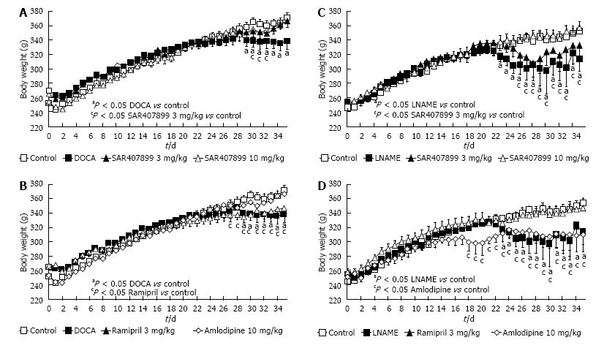
Figure 1 Effect of SAR407899 on body weight in deoxycorticosterone acetate and Nω-Nitro-L-arginine methyl ester hydrochloride hypertensive animals. A and B: Body weight of deoxycorticosterone acetate (DOCA) rats. A significant decrease in body weight was observed after 28 d; A: Effect of SAR407899 at 3 mg/kg and 10 mg/kg on body weight. Both doses protected DOCA rats against body weight loss; B: Effect of ramipril at 1 mg/kg and amlodipine at 3 mg/kg on body weight. Only amlodipine showed protective effects on body weight loss; C and D: Body weight of N-Nitro-L-arginine methyl ester hydrochloride (LNAME) rats. A significant decrease in body weight was observed after 22 d. C: SAR407899 at 10 mg/kg significantly protected LNAME rats from body weight loss; D: Effect of ramipril at 1 mg/kg and amlodipine at 3 mg/kg on body weight. Only ramipril showed significant protective effects on body weight loss.
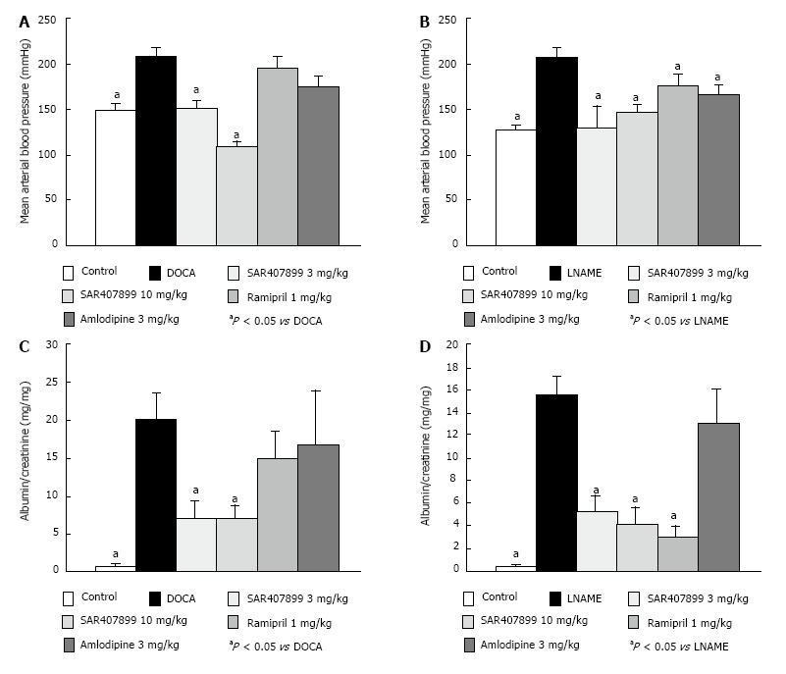
Figure 2 SAR407899 efficiently lowers blood pressure, proteinuria and mortality in hypertensive rats. Invasive measurement of blood pressure in deoxycorticosterone acetate (DOCA) (A) and in Nω-Nitro-L-arginine methyl ester hydrochloride (LNAME) (B) rats. At the given dose, SAR407899 showed superior blood pressure lowering effect in comparison to ramipril and amlodipine in both animal models; C and D: Assessment of kidney function in DOCA and LNAME rats. SAR407899 showed significant protective effects on the kidneys in both models, whereas ramipril reduced albuminuria only in the LNAME model. Amlodipine had no therapeutic effect on kidney in either model.
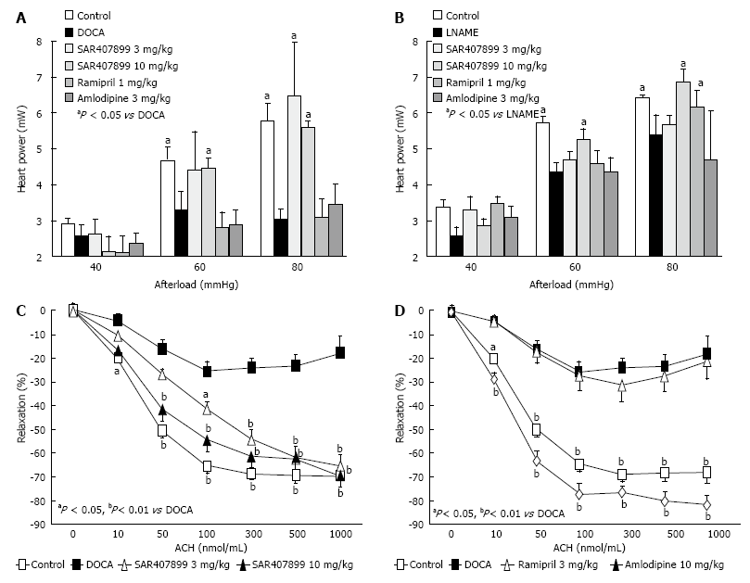
Figure 3 Effect of SAR407899 on heart and endothelial function. Measurement of heart function of isolated hearts of deoxycorticosterone acetate (DOCA) (A) and Nω-Nitro-L-arginine methyl ester hydrochloride (LNAME)-treated rats (B). SAR407899 showed a significant improvement of heart function compared to reference substances at both doses and in both models; C and D: Measurement of endothelial function of aortas of DOCA rats treated with SAR407899 (C) or with reference substances (D). Ramipril treatment had no effect on endothelial function. Long-term treatment with SAR407899 improved endothelial function in a dose-dependent fashion. Amlodipine had similar protective effects as SAR407899.
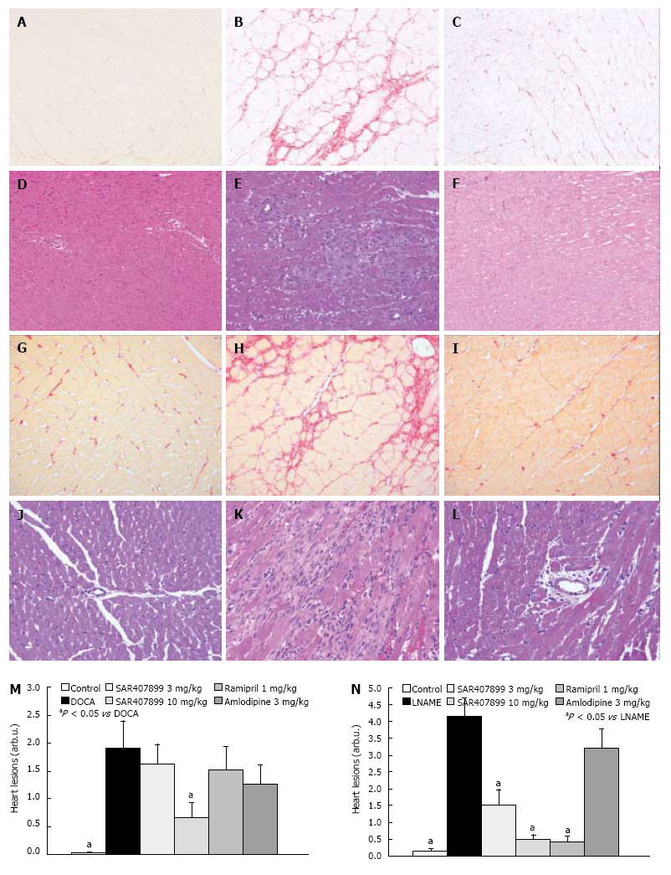
Figure 4 Histological examination of the effect of SAR407899 on the heart. Sirius red staining of hearts of deoxycorticosterone acetate (DOCA) (A-C) and Nω-Nitro-L-arginine methyl ester hydrochloride (LNAME) rats (G-I) showed a strong induction of myocardial fibrosis. Upon treatment with SAR407899 at 10 mg/kg, significant protective effects were observed. Haematoxylin eosin staining of hearts of DOCA (D-F) and LNAME rats (J-L) showed perivascular fibrosis, massive infiltration of leukocytes into the interstitium and sclerotic changes. SAR407899 treatment at 10 mg/kg attenuated multifocal fibrosis, perivascular fibrosis and leukocyte infiltration. M and N: Summary of heart lesions and the effect of SAR407899 and reference substances in DOCA (M) and LNAME rats (N). A, D, G, J: Control; B, E: DOCA; H, K: LNAME; C, F, I, L: SAR407899 10 mg/kg.
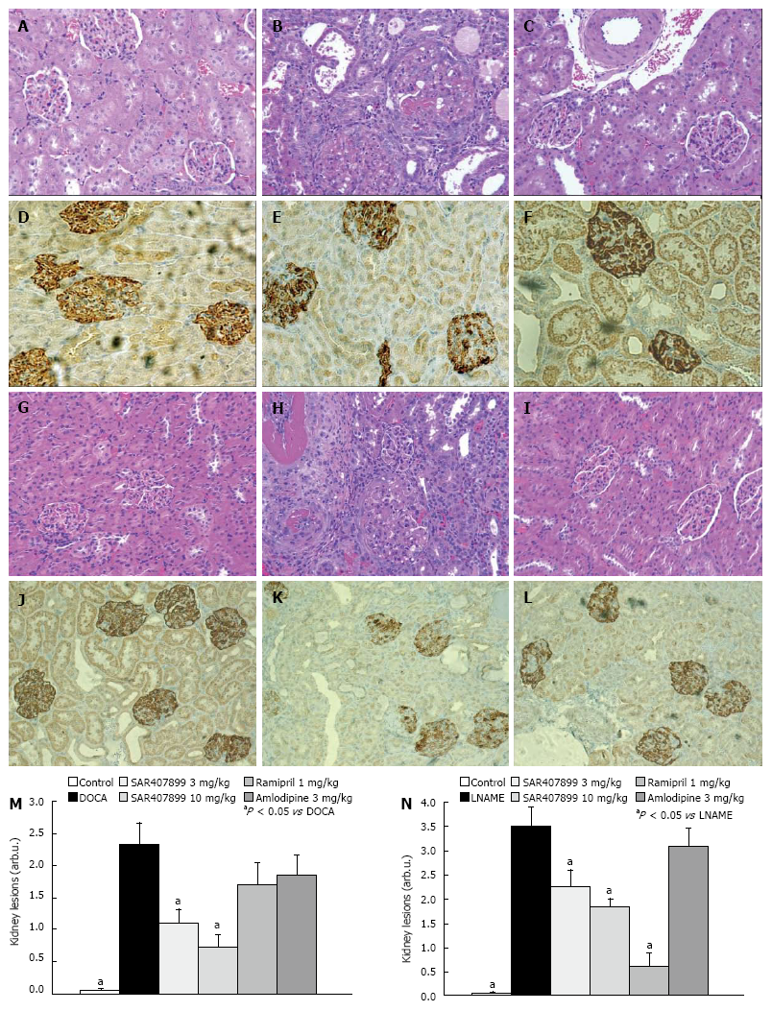
Figure 5 Histological examination of the effect of SAR407899 on the kidney. A-C: Haematoxylin eosin staining of normal glomeruli in control rats (left), sclerotic changes, dilation and hypertrophy of glomeruli of deoxycorticosterone acetate (DOCA) rats (center) and protective effects of SAR407899 at 10 mg/kg (right); D-F: Podocin staining in kidneys. Upon DOCA treatment, massive loss of podocytes can be detected. SAR407899 at 10 mg/kg exerts a protective effect in the kidneys of DOCA rats and rescues podocytes; G-I: Haematoxylin eosin staining of normal glomeruli in control rats (left), severe fibrotic changes, infiltration of leukocytes, and hypertrophy of glomeruli of Nω-Nitro-L-arginine methyl ester hydrochloride (LNAME) rats (center), protective effects of SAR407899 at 10 mg/kg (right); J-L: Loss of podocytes upon LNAME treatment. SAR407899 at 10 mg/kg protected against loss of podocytes. Summary of kidney lesions and effect of SAR407899 and reference substances in DOCA (M) and LNAME rats (N). A, D, G, J: Control; B, E: DOCA; H, K: LNAME; C, F, I, L: SAR407899 10 mg/kg.
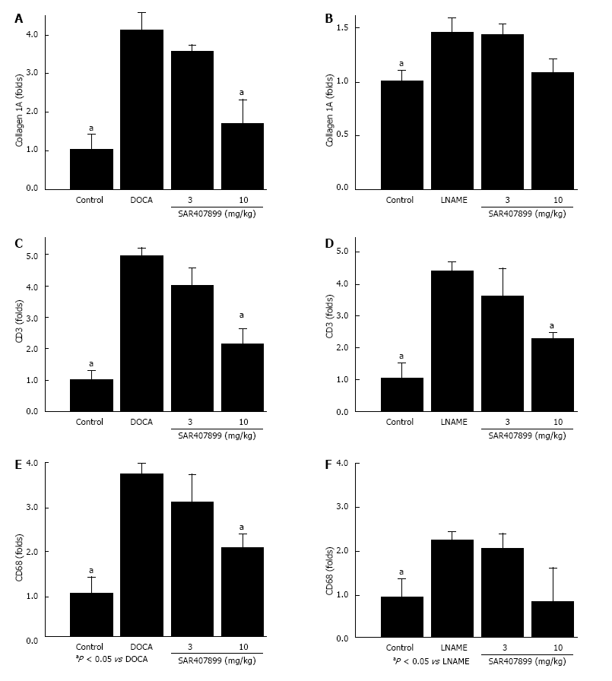
Figure 6 Effect of SAR407899 on the expression of fibrotic and leukocyte genes in the kidney. Determination of collagen, T cell (CD3) and macrophage (CD68) expression in the kidneys of deoxycorticosterone acetate (DOCA) (A, C and E) and Nω-Nitro-L-arginine methyl ester hydrochloride (LNAME) (B, D and F) rats. Expression of collagen was significantly increased upon DOCA and LNAME treatment. Upon DOCA or LNAME treatment, CD3 and CD68 abundance was induced, indicating that leukocytes infiltrated into the kidneys. SAR407899 treatment reduced expression of collagen and leukocyte genes in both models.

